Assessment of Official Meetings Using Detailed Evaluation and Prediction Analysis (DEPA) Model Empowered with Machine Learning

(Project Proposal)



Project Code:
< >

Project Advisor
Sir Saad Razzaq

Project Manager:

Sir Fahad Maqbool
Submission Date:

October 03, 2023

Project Team:

Sr. No | Name | Roll No | Role
1 | Sahrish Munir | BSEF19M010 | Team Lead
2 | Maria Farooq | BSSE51F20R047 | Team Member
3 | Nimra Bibi | BSSE51F20R020 | Team Member

Table of Contents
1. Abstract 3
2. Background and Justification 3
3. Project Methodology 3
4. Project Scope 6
5. High level Project Plan 6
6. References 6

Abstract:
In the rapidly evolving landscape of the software IT industry, the quality of meetings and effective decision-making are paramount. The proposed Detailed Evaluation Prediction Analysis (DEPA) model addresses the challenge of relying on subjective feedback from managers by introducing a machine learning-powered system that categorizes meetings as Good, Bad, or Average. This model, integrated with Google Calendar, enables automated meeting assessment and authentication of users. It aims to reduce communication gaps, enhance decision-making, and evaluate employee assessments, contributing significantly to the industry. By incorporating machine learning techniques, DEPA promises to optimize meetings, improve decision quality, and foster efficient resource utilization, with potential applications extending beyond the software IT sector.

- Background and Justification:

Meyer, Adomavičius, Johnson, and Elidrisi (2014) explored dynamic decision-making in complex domains. They introduced an iterative approach using data mining classification techniques to identify conditions under which dynamic decision strategies produce undesirable outcomes. They applied this approach to the healthcare management field, specifically in the treatment of patients with type 2 diabetes, based on electronic medical records.

Alhawamdeh and Alsmairat (2019) examined decision strategy improvements in the context of manufacturing problems. Their study focused on the relevance of strategic decision-making in organizational performance. They found that environmental factors, leadership behavior, organizational justice, decision approach, and process significantly influenced managers' decisions and performance. Decision support systems were highlighted for their role in delivering timely information to enhance performance.

Bastani and Sinchaisri (2021) discussed the challenge of making machine learning models more interpretable for humans. They introduced a system that communicates machine learning insights to users in the form of interpretable "tips," particularly focusing on sequential decision-making. Their research involved randomized controlled user tests in a virtual kitchen setting, demonstrating that these "tips" substantially improved human performance. The study offered valuable insights for the development of algorithms for human-AI interfaces.

These studies collectively contribute to the understanding of decision-making processes, the impact of strategic decisions on organizational performance, and the development of more user-friendly machine learning models.

Project Methodology:
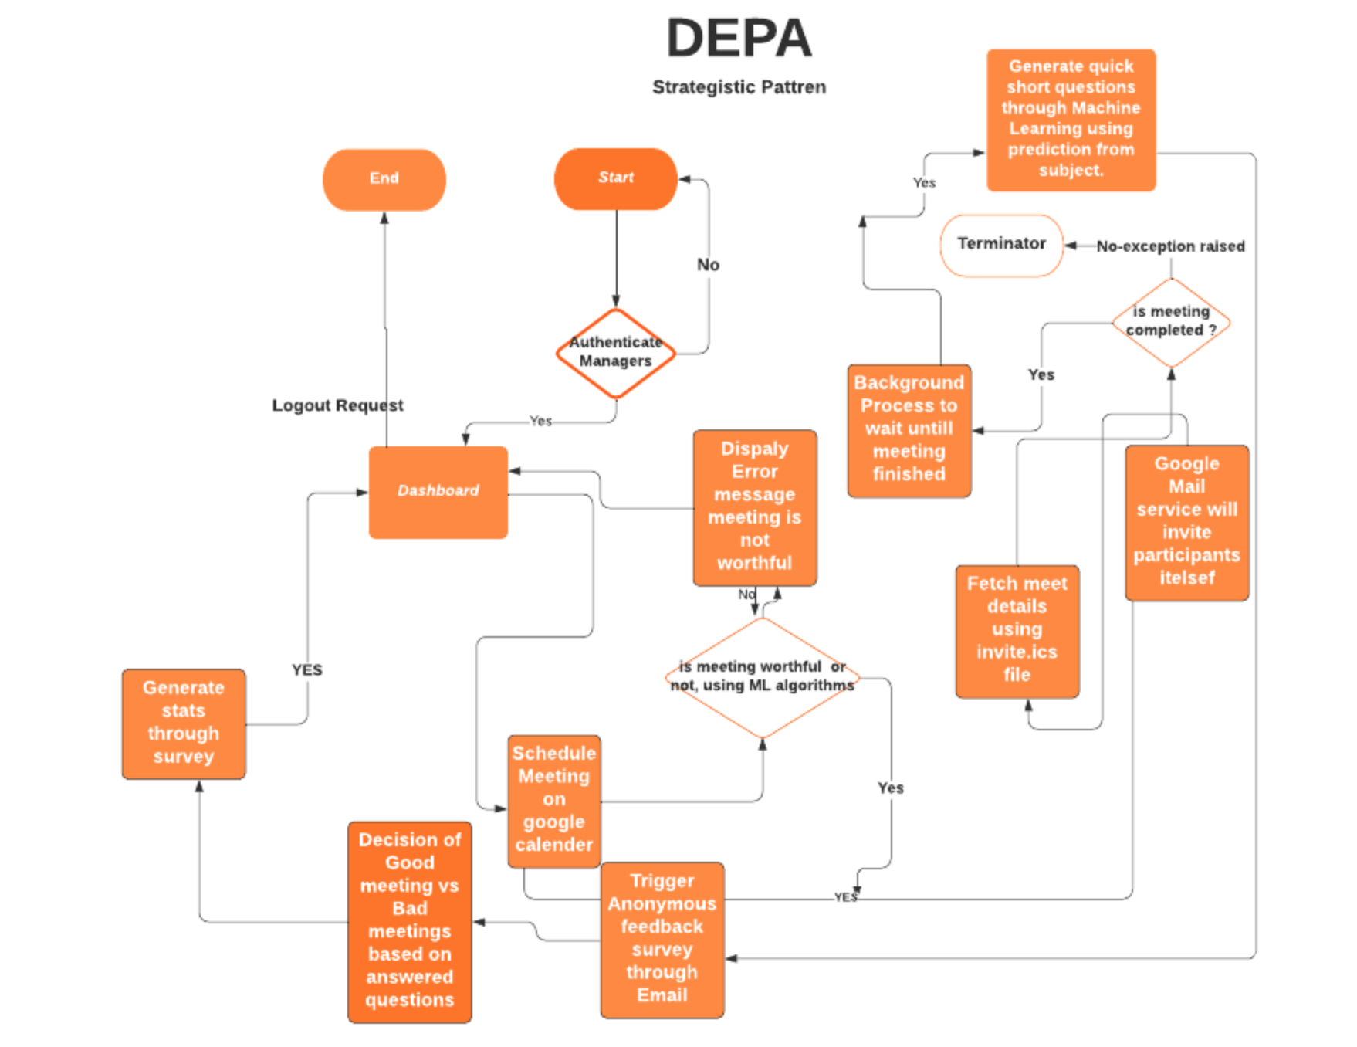
The method will organize meetings through Google Calendar by inviting people, and then decision tree algorithms will assess whether the meeting is beneficial or not based on the subject and meeting agenda. If the meeting isn't worthwhile, the model will display a note on the dashboard stating that the meeting isn't worthwhile due to previous experience, but if you still want to go, please do so. Managers will be able to schedule meetings using Google Calendar, and a background process will use the Node run time environment to track when the meeting will end.

Figure 1: Proposed DEPA Model

The system will auto construct a brief few questions from the data in the dataset by filtering the subject keywords and will automatically send an email to the participants once the meeting has concluded, as indicated by the data retrieved from the Google calendar invite file. When participants complete the survey questions, they will be added anonymously to the system, obscuring the user's identity and compromising the security and confidentiality of the users.
When the answers are entered into the system, the system generates statistics and logs them into the system for future reference. And assign classification labels to the meeting, such as GOOD MEETING, BAD MEETING, or AVG MEETING. The status of the conference will be classified using an expression formula.

s = count of answered questions/ total questions

By dividing the number of answered questions by the total number of questions asked at each meeting, s represents the meeting's status. The following expression will be used to acquire the aggregate of stats meetings.

Avg (s) = Σ s(i) / Σ of total number of questions

The average is calculated by dividing the sum of each meeting by the number of count questions. If the result is less than 50 out of 100, the meeting is considered BAD; however, if the result is between 50 and 70, the meeting is considered AVG; and if the result is greater than 70, the meeting is considered GOOD.
The proposed model includes a prediction factor that will be determined by the Decision tree technique. To see how accurate the decision tree algorithm will be. The accuracy formula will be used to generate dot files, which will be used to express accuracy in visual form. Jupiter will be used to write and execute the code for the algorithm, and the Django REST framework will be utilized to construct the APIs in the system. Let's take a closer look at the dataset and the code that uses supervised machine learning techniques to implement it.

Project Scope:

This project aims to enhance productivity in the software IT industry by introducing the Detailed Evaluation Prediction Analysis (DEPA) Model for efficient management of organizational meetings. By implementing machine learning algorithms, the system categorizes meetings as Good, Bad, or Average, reducing reliance on subjective feedback. It seeks to prioritize meetings, improve decision-making processes, and bridge communication gaps. The project also includes evaluating employee assessments through DEPA using machine learning. Practical applications involve predicting meeting outcomes, improving feedback systems, and creating web portals. While limitations exist, future research will refine the model for broader organizational use.

High level Project Plan:

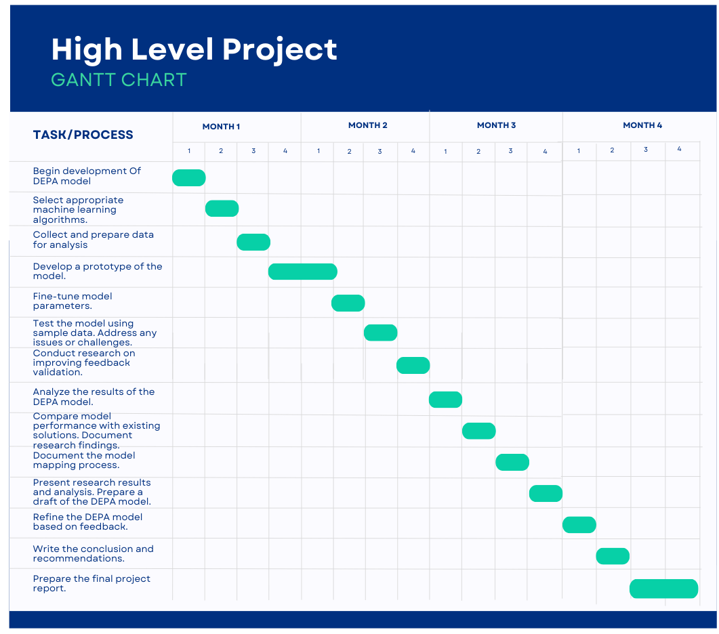

References
- Alhawamdeh, Hamzeh M., and Mohammad AK Alsmairat. "Strategic decision making and organization performance: A literature review." International review of management and marketing 9.4 (2019): 95.

- Alyoubi, Bader A. "Decision support system and knowledge-based strategic management." Procedia Computer Science 65 (2015): 278-284.

- Bastani, Hamsa, Osbert Bastani, and Wichinpong Park Sinchaisri. "Improving human decision-making with machine learning." arXiv preprint arXiv:2108.08454 (2021).

- Claudé, Mélanie, and Dorian Combe. "The roles of artificial intelligence and humans in decision making: Towards augmented humans." A focus on knowledge-intensive firms (2018).

- Kitsios, Fotis, and Maria Kamariotou. "Decision support systems and business strategy: a conceptual framework for strategic information systems planning." 2016 6th International Conference on IT Convergence and Security (ICITCS). IEEE, 2016.

- Kitsios, Fotis, and Maria Kamariotou. "Decision support systems and strategic planning: information technology and SMEs' performance." International Journal of Decision Support Systems 3.1-2 (2018): 53-70.

- Meyer, Georg, et al. "A machine learning approach to improving dynamic decision making." Information Systems Research 25.2 (2014): 239-263.

- Nieto, Yuri, et al. "Usage of machine learning for strategic decision making at higher educational institutions." IEEE Access 7 (2019): 75007-75017.
- Pomerol, Jean-Charles. "Artificial intelligence and human decision making." European Journal of Operational Research 99.1 (1997): 3-25.

- Song, Hummy, et al. "Closing the productivity gap: Improving worker productivity through public relative performance feedback and validation of best practices." Management Science 64.6 (2018): 2628-2649.

- Stone, Merlin, et al. "Artificial intelligence (AI) in strategic marketing decision-making: a research agenda." The Bottom Line 33.2 (2020): 183-200.

- Shrestha, Yash Raj, Shiko M. Ben-Menahem, and Georg Von Krogh. "Organizational decision-making structures in the age of artificial intelligence." California management review 61.4 (2019): 66-83.

